Master of Science Program in Marriage and Family Therapy
On-Campus Learning

Program Specific Application
Fall 2023

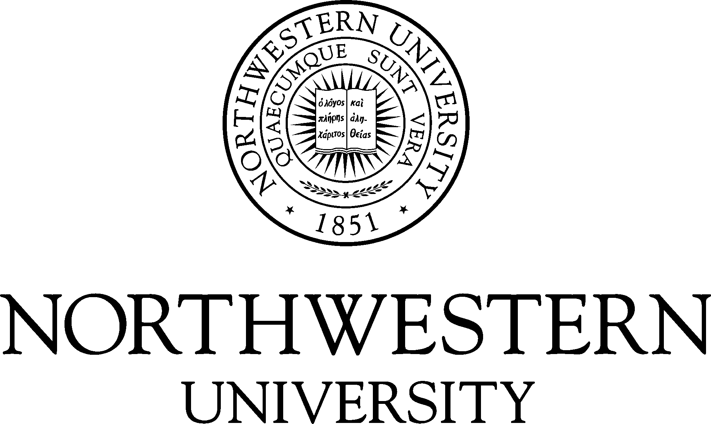

The Center for Applied Psychological and Family Studies
in conjunction with The Graduate School and The Family Institute
at Northwestern University

Center for Applied Psychological and Family Studies
618 Library Place
Evanston, IL 60201

MSMFT Program Website

Application Deadline and Options

Applications for admission are accepted beginning September 6, 2022, for admission for the 2023-2024 Academic Year. You may apply *Early Decision or Regular Decision. Program slots tend to fill quickly so we encourage you to submit your application as early as possible.

Application Deadline
Early Decision | November 4, 2022
Regular Decision | December 31, 2022

Early Decision

If you are certain that Northwestern is where you want to study, we encourage you to apply under our Early Decision plan. As with all traditional Early Decision plans, if admitted, you agree to withdraw all applications at other colleges and enroll at Northwestern in the Fall.

Applicants who choose Early Decision send a strong, positive message to Northwestern. Given their high level of interest and overall academic and personal strength, Early Decision applicants enjoy a higher rate of admission.

Applicants who apply for *Early Decision admission may be invited to attend the exclusive Master of Science in Marriage and Family Therapy Program Early Admission Interview. During the interview, applicants will meet the MSMFT Program core faculty and some of the current students, participate in a group interview, and learn more about the program. We admit qualified applicants in the Early Decision applicant pool first. Early admission decisions are typically made within 2 weeks after the interview.

Those applicants who apply for Early Decision but are not admitted are placed in the Regular Decision applicant pool upon request by the applicant.

Regular Decision

Applicants who apply for Regular Decision may be invited to attend the Master of Science in Marriage and Family Therapy Regular Admission Interview. During the interview, applicants will meet the MSMFT Program core faculty and some of the current students, participate in a group interview, and learn more about the program. Admission decisions for regular decision applicants are made on a rolling basis.

Master of Science Program in Marriage and Family Therapy
Northwestern and Program Specific Application and Checklist
INSTRUCTIONS TO APPLICANTS

The items that follow are required by the relevant deadlines to complete an application to the Master of Science Program in Marriage and Family Therapy. Applications will not be reviewed until all required materials have been received.

PART I: Northwestern University Graduate School Application Requirements
The Graduate School on-line application is available at https://www.applyweb.com/nugrad/index.ftl

Complete an on-line application through The Graduate School’s CollegeNET system.
Upload transcripts from all schools attended post high school through CollegeNET system.
Digitally submit two (2) letters of recommendation through CollegeNET system.
5,000-character Statement of Purpose (please see instruction below)
Upload resume through CollegeNET system.
Submit Test of English as Foreign Language (TOEFL) scores for international students only (using code 1565).
Pay application fee of $95.00 by credit card at application submission.

PART II: Program-Specific Application Requirements
The following materials must be uploaded to the Graduate School on-line application

Program Specific Application – Master of Science in Marriage and Family Therapy Program
Upload a recent Photo of yourself (for identification purposes)
Applications for scholarship and assistantships

If you have any questions about the MSFT application process, please contact MSFT Admissions,
(847) 733-4300, extension 206 or MSFTAdmissions@family-institute.org

Master of Science Program in Marriage and Family Therapy
Program Specific Application for Admission

Biographical Information
Last Name | First Name | Middle | Maiden
Address |  | City | State | Postal Code
Home Phone | Cell Phone | Email Address

Admissions Deadline & Options
Please check if you are applying Early Decision or Regular Decision
Early Decision | November 4, 2022, Deadline
Regular Decision | December 31, 2022, Deadline

Employment and School History
Please attach a detailed resume or curriculum vitae accounting for all time periods from the start of your undergraduate studies to the present, beginning with your most recent activities. Please include schooling, part-time, summer, and full-time work experience, travel, job search, etc. Specify dates, employer/school, job title, average number of hours per week, and primary responsibilities. Pay particular attention to describing activities in the field of mental health.

Disclosures
If your answer to either of the following questions is yes, explain fully on an attached sheet:
(Please see University Policy statement below regarding non-discrimination)

Do you have a known disability (physical or emotional) that requires special accommodations? | Yes | No
Have you ever been suspended or required to withdraw from any school or college? | Yes | No
Have you ever pled “guilty” or” no contest” to, or been convicted of a crime? | Yes | No
Answering “yes” to these questions does not constitute an automatic bar from admissions. Factors such as date of offense, seriousness and nature of the violation and rehabilitation will be taken into account.

The Family Institute at Northwestern University requires all applicants who have received conditional admission to either the Master of Arts Program in Counseling Psychology or the Master of Science Program in Marriage and Family Therapy to complete an online background check to determine criminal history. Having an adverse criminal history finding does not necessarily preclude admission. Determinations are considered on a case-by-case basis. In the event that information from the background report is utilized in whole or in part in making an adverse decision with regard to an applicant's admission, before making the adverse decision, the Institute will provide the student with a copy of the consumer report and a written description of his or her rights under the federal Fair Credit Reporting Act.

University Policy Statements
It is the policy of Northwestern University not to discriminate against any individual on the basis of race, color, religion, national origin, sex, sexual orientation, marital status, age, handicap, or veteran status in matters of admissions, employment, housing, or services or in the educational programs or activities it operates, in accordance with civil rights legislation and University commitment. Any alleged violations of this policy or questions regarding the law with respect to non-discrimination should be directed to Director of Equal Employment Opportunity, Affirmative Action, and Disability Services, 720 University Place, Evanston, Illinois 60208-1147, 847/491-7458: Office of the Provost, Rebecca Crown Center, 633 Clark Street, Evanston, Illinois 60208-1101. Northwestern University reserves the right to change without notice any statement in this application concerning, but not limited to, rules, policies, tuition, fees, curricula, and courses.

Other Mental Health Programs Applied
Please check the number of programs you are applying to in each of the following disciplines:

Marriage & Family Therapy | 0 | 1 | 2 | 3+
Social Work | 0 | 1 | 2 | 3+
Clinical Psychology | 0 | 1 | 2 | 3+
Counseling Psychology | 0 | 1 | 2 | 3+

NU Statement of Purpose
Please respond to the following question in your NU Statement of Purpose within 5000 characters or less.

The Admissions Committee is most interested in you, the person, who seeks to be a marriage and family therapist. Your Statement of Purpose should be written so that we may better know you. Please respond to the following questions.

- What personal and family experiences have influenced your interest in a career as a marriage and family therapist?
- What academic and professional experiences have influenced your interest in a career as a marriage and family therapist?
- What attracts you to the field of marriage and family therapy (as opposed to social work, counseling, or clinical psychology)?
- What attracts you to the MSMFT Program here at Northwestern University?
- Describe a time in your life when things didn’t go well for you. Describe the circumstances of this time and how you handled the challenges associated with it.

References
Applicants for degree programs are required to submit two (2) letters of reference. References should include, if possible, at least one addressing the applicant's academic background. Reference Letters must be submitted through The Graduate School’s CollegeNet Application system.
----------------------------------------------------------------------------------------------------------------------------------------------------------------

Northwestern University does not find it possible to admit all applicants who meet its entrance requirements. The University, therefore, reserves the right to refuse admission to any applicant. The University also reserves the right to require the withdrawal of any student whose condition endangers his or her own health or the health of other students or precludes him or her from doing the required work.

I certify that all statements made in this application for admission to the Master of Science in Marriage and Family Therapy Program in The Graduate School of Northwestern University are correct, and I realize that all documents submitted in support of this application become the property of Northwestern University.

Signature | Date

Northwestern University
Master of Science in Marriage and Family Therapy
Applicant Acknowledgement of Regulatory Alignment

Marriage and Family Therapy (MFT) is a profession that leads to licensure in all 50 states; however, each state has its own law and regulations about what is needed to become licensed as a MFT in that state.

Not every state will accept a degree and supervised hours earned in another state. Review license requirements in the state you intend to practice as soon as possible so that you understand what may and may not be accepted across state lines. Here is the link to information about each state’s licensure resources: MFT State/Provincial Resources (AAMFT.org)

The coursework for the Master of Science in Marriage and Family Therapy (MSMFT) program at Northwestern University was designed to meet MFT licensure requirements in the state of Illinois. You may read more about the state requirements for MFT licensure in Illinois by clicking this link: Illinois Department of Financial and Professional Regulation - MFT Licensing Information

If you have questions about the program’s alignment with professional licensure you may contact the Department Chair: Dr. Mudita Rastogi.

Please sign this form and return with your program admissions application.

It is recommended that you keep a copy of this form in your files.

I acknowledge that I have been informed and am aware that licensing regulations differ across states and provinces. I understand that Northwestern University’s MSMFT program is designed to meet the licensure requirements in the state of Illinois, and that an MFT degree from this program may not meet MFT licensing requirements in a different state.

Printed name as shown in application
Signature | Date

