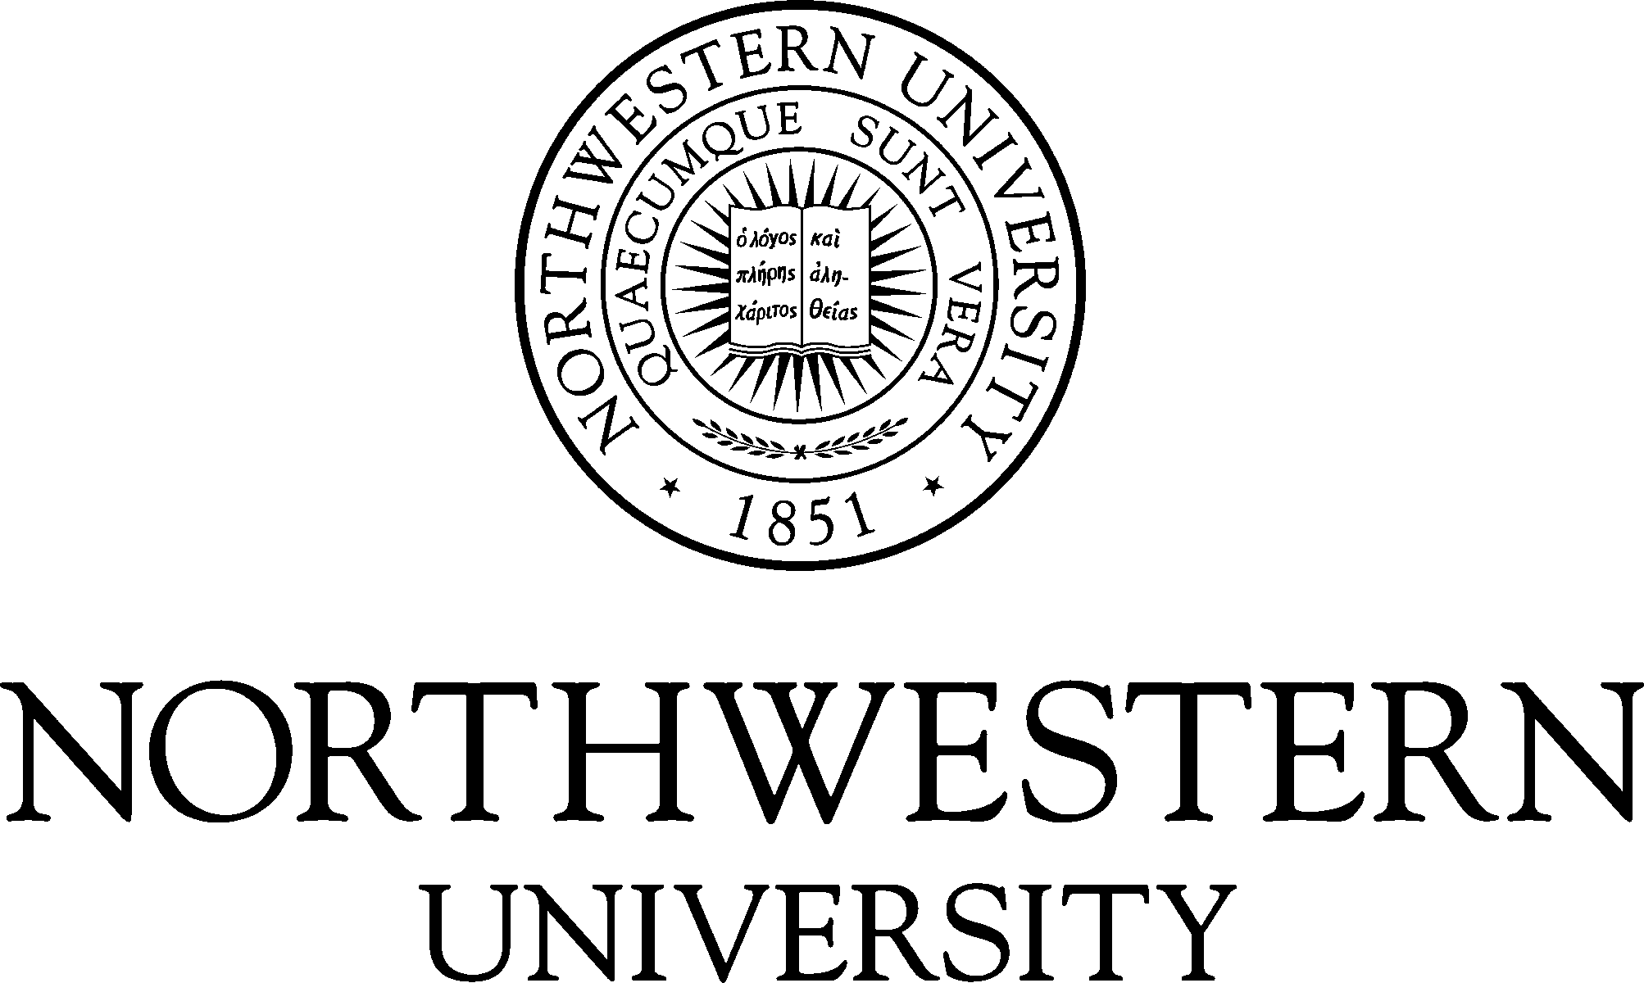

The Center for Applied Psychological and Family Studies
in conjunction with The Graduate School and The Family Institute
at Northwestern University

Master of Arts in Counseling Program

Program Specific Application for Admission
for Academic Year 2018-2019

Center for Applied Psychological and Family Studies
618 Library Place
Evanston, IL 60201
Counseling Program Website
Applicant Information
Applications for admission are accepted beginning September 4, 2018 for admission for the 2018-2019 Academic Year. 28 students typically enter the program each year, including some who qualify for the Standard Curriculum and others who qualify for the Two-Plus Curriculum. The Standard curriculum is appropriate for applicants with a background in counseling, psychology or other human service fields, and the Two-Plus Curriculum is appropriate for applicants who are career changers from an array of different academic and professional backgrounds.

All applicants will be invited to participate in an admission interview at the Northwestern University Evanston Campus on the weekend of February 16, 2019. During the interview, applicants will meet the Counseling Program core faculty and program students, participate in a group interview, learn more about the program and tour The Family Institute headquarters and Northwestern University campus. The admissions committee will convene following the completion of all interviews and applicants will be notified of their admission status on March 18, 2019.

Application Deadline | Admission Interview | Admission Decisions
December 15, 2018 | February 16, 2019 | March 18, 2019

Applicants who submit an application for a financial scholarship or assistantship, will be notified of the award decision around the time of their acceptance of the offer of admission to the program.

Required Materials

The items that follow are required by the relevant deadlines to complete an application to the Master of Arts in Counseling Program. Applications will not be reviewed until all required materials have been received.

Instructions for Application PART 1:

APPLICATION PART 1: What do I submit? | How do I submit it?
1. Online application to The Graduate School through CollegeNET | Accessed through TGS Web site
2. Apply Yourself application fee of $95.00 | Submitted through Apply Yourself
3. Official Test of English as a Foreign Language (TOEFL) scores
4. Two official transcripts from each institution(s) attended since secondary school
5. Minimum of two letters of recommendation

- Complete an online application through CollegeNET accessed through TGS Web site.

- Pay the CollegeNET application fee of $95.00 by credit card at application submission.

- Submit official Test of English as a Foreign Language (TOEFL) scores directly from Educational Testing Service to Northwestern University using institution code #1565 and object code 01. Applicants must submit official scores for the Test of English as a Foreign Language (TOEFL) taken within the last two years.

- Upload scanned versions of official transcripts online in CollegeNET. We require a transcript for every institution attended since secondary school and a transcript must be submitted for every institution listed in CollegeNET.

- Submit letters of recommendation online in CollegeNET. We require a minimum of two letters of recommendation addressing the applicant's ability to do scholarly work. There is no official form to accompany this letter.

Instructions for Application PART 2:

APPLICATION PART 2: What do I submit? | How do I submit it?
6. Master of Arts in Counseling Program Specific Application | Downloaded from this Web site
7. Resume or vita | Submitted with Program Specific Application
8. Four supplemental essays
9. Recent photo of yourself
10. Application for Scholarships and Assistantships | Downloaded from this Web site

- Master of Arts in Counseling Program Specific Application which is available as a PDF file.

- Resume or Curriculum Vitae.

- The following four supplemental essays of a minimum of one page each which can be written separately or combined into one essay with sub-headings, and consist of the following:
  - brief autobiographical statement
  - clear and thoughtful statement of professional interests and goals
  - summary of prior clinical training, work experience and direct experience with professional psychology or counseling
  - a thoughtful statement answering the question, "Why do I think I am suited to the field of professional counseling?"

- Scanned copy of a recent photo of yourself.

- The Application for Scholarships and Assistantships which is available as a PDF file.

Biographical Information

First Name | Middle Initial | Last Name |  | Maiden Name
Mailing Address |  | City |  | State | Postal Code
Phone Number |  | Email Address
How did you hear about the Counseling Program at Northwestern University?
Have you ever been suspended or required to withdraw from any school or college? |  |  | Yes |  | No
If you answered yes above, please explain.
Have you ever been separated from any branch of the armed forces of the united states under conditions other than honorable? |  |  | Yes |  | No
If you answered yes above, please explain.
Have you ever pled guilty or no contest to, or been convicted of a crime? |  |  | Yes |  | No
If you answered yes above, please explain.
Answering yes to the questions above does not constitute an automatic bar from admissions. Factors such as date of offense, seriousness and nature of the violation, and rehabilitation will be taken into account. The Family Institute at Northwestern University requires all applicants who have received conditional admission to either the Master of Arts in Counseling Program or the Master of Science in Marital and Family Therapy Program to complete an online background check to determine criminal history. Having an adverse criminal history finding does not necessarily preclude admission. Determinations are considered on a case by case basis. In the event that information from the background report is utilized in whole or part in making an adverse decision with regards to applicant admission, before making the adverse decision, the institute will provide the applicant with a copy of the consumer report and a written description of his or her rights under the federal Fair Credit Reporting Act.

Curriculum Selection

You must apply either as a Standard Curriculum applicant or a Two-Plus Curriculum applicant.
To apply as a Standard Curriculum Applicant, prior to entering the Counseling Program, you must have:
- at least ONE academic experience and at least TWO clinical experiences
or
- NO academic experiences and at least THREE clinical experiences

Apply as a Two-Plus Curriculum Applicant if you have:
- NO academic experiences and TWO or fewer clinical experiences
or
- NO academic or clinical experiences
Check the box indicating the Curriculum for which you are applying:
Standard Two-Year Curriculum Applicant | Two-Plus Three-Year Curriculum Applicant
Indicate your academic and clinical experiences below. Each experience listed must be described in your resume. The Admissions Committee will review your academic and clinical experiences and make a final curriculum determination.
Category 1: Academic Experience – Indicate your academic experiences in the following four areas:
Required Academic Experience: |  | Your Academic Experience:
- Psychology or human services undergraduate degree
- Psychology or human services minor
- At least two (2) graduate psychology or human services courses that are clinical in nature
- At least four (4) undergraduate psychology or human services courses that are clinical in nature (e.g., abnormal, personality, human development, and/or introduction to psychology)
Category 2: Clinical Experience - Indicate your clinical experiences in the following five areas:
Required Clinical Experience: |  | Your Academic Experience:
- Supervised training in a clinical environment such as a crisis/domestic abuse/sexual abuse training
- Documented training in active listening
- Paid work experience in a clinical setting such as a case manager or counselor
- Experience as a Resident Assistant
- Experience as a Peer Mentor

Specialization Selection

Required Specialization Courses
There are two specialization tracks available to students; 1.) Psychological Counseling Track or 2.) Child Assessment and Intervention Track. Each specialization requires the student to enroll in an assessment, development, therapy and elective course and to complete a fieldwork experience related to the area of professional interest. Applicants declare a specialization and specialization courses begin in Winter Quarter of the first year in the program.
The following specialization courses are included in the 24 courses required for the Standard Curriculum and the 27 courses required for the Two-Plus Curriculum:
 | Psychological Counseling Track |  |  | Child Assessment & Intervention Track
Assessment Course | 426-21 Assessment in Counseling (Adult Focus) |  |  | 426-20 Assessment in Counseling (Child Focus)
Development Course | 414-21 Human Growth and Development (Adult Focus) |  |  | 414-20 Human Growth and Development (Child Focus)
Therapy Course | 417 Cognitive Behavioral Therapy with Adults & Children |  |  | 436 Child Psychotherapy
Elective Course | 453 Evaluation and Treatment of Trauma Disorders |  |  | 453 Evaluation and Treatment of Trauma Disorders
You must select a specialization in either Psychological Counseling or Child Assessment and Intervention below.
Check the box indicating your Specialization Track: |  |  | Psychological Counseling Track |  | Child Assessment and Intervention Track
If you selected the Child Assessment and Intervention Track, answer the following questions:
What experiences have you had working with children and adolescents?
Why do you want to work with children and adolescents?

Resume or Curriculum Vitae

Please attach a detailed resume or curriculum vitae accounting for all time periods from the start of your undergraduate studies to the present, beginning with your most recent activities. Describe those academic and clinical experiences that you listed in the Curriculum Selection chart above. Include schooling, part-time, summer and full-time work experience, travel, job search, etc. Specify dates, employer/school, job title, average number of hours per week, and primary responsibilities. Pay particular attention to describing activities in the field of mental health.

List honors received or other evidence of high scholarship (Phi Beta Kappa, Beta Gamma Sigma, etc.):
Describe your employment while in college:
Hours per week spent working during the following college years:
 | Freshman |  | Sophomore |  | Junior |  | Senior

Extracurricular Activities and Professional Organizations

Please list organizations of highest importance first.

Organization Name | Dates of Membership |  | Brief Description of Activity | Offices Held
 | From | Click here to enter a date.
 | To | Click here to enter a date.
 | From | Click here to enter a date.
 | To | Click here to enter a date.
 | From | Click here to enter a date.
 | To | Click here to enter a date.

Supplemental Essays

In addition to the purpose/personal statement that is part of the on-line application, applicants must submit four additional supplementary essays of a minimum of one page each; these essays can be written separately or combined into one essay with sub-headings, and consist of the following:

- a brief autobiographical statement
- a clear and thoughtful statement of professional interests and goals
- a summary of prior clinical training, work experience and direct experience with professional psychology or counseling
- a thoughtful statement answering the question, "Why do I think I am suited to the field of professional counseling?"

References
You will submit letters of recommendation online in Apply Yourself. We require a minimum of two letters of recommendation addressing your ability to do scholarly work. There is no official form to accompany this letter.
For each reference that will be submitted for you, provide the following information:

First Name | Last Name | Position
Mailing Address | City | State | Postal Code
First Name | Last Name | Position
Mailing Address | City | State | Postal Code
First Name | Last Name | Position
Mailing Address | City | State | Postal Code

Northwestern University does not find it possible to admit all applicants who meet its entrance requirements. The University, therefore, reserves the right to refuse admission to any applicant. The University also reserves the right to require the withdrawal of any student whose condition endangers his or her own health or the health of other students or precludes him or her from doing the required work. It is the policy of The Family Institute at Northwestern University not to discriminate against any individual on the basis of race, color, religion, ancestry, national origin, citizenship status, age, sex, marital status, genetic information, sexual orientation, gender expression, gender identity, non-disqualifying disability or veteran/military status in matters of admissions, employment, or services. Services include all clinical services, educational programs or research activities the Institute operates. The staff, faculty, and Board of Directors of The Family Institute are fully committed to function in accordance with all applicable federal, state and local laws regarding non-discrimination. Any alleged violations of this policy or questions regarding the law with respect to nondiscrimination should be directed to the Vice President for Quality Assurance and Evaluation, as well as to the Office of the Provost, Rebecca Crown Center, Evanston, Illinois 60208-1101, phone (847) 491-5117; Office of the Equal Opportunity Officer and Handicap Services Coordinator, 720 University Place, Evanston, Illinois 60208-1147, phone (847) 491-7458. Northwestern University reserves the right to change any statement in this packet concerning, but not limited to, rules, policies, tuition, fees, curricula, and courses.
I certify that all statements made in this application for admission to the Master of Arts in Counseling Program in The Graduate School of Northwestern University are correct, and I realize that all documents submitted in support of this application become the property of Northwestern University.
Type Your Signature | Date
 | Click here to enter a date.
Submit the Program Specific Application along with your resume, supplemental essays, scanned copy of a recent photo of yourself and if applicable, the Application for Scholarships and Assistantships to Deidre Hicks, Education Coordinator at the following email address: dhicks@family-institute.org

