Master of Science Program in Marriage and Family Therapy

Program Specific Application
Fall 2019

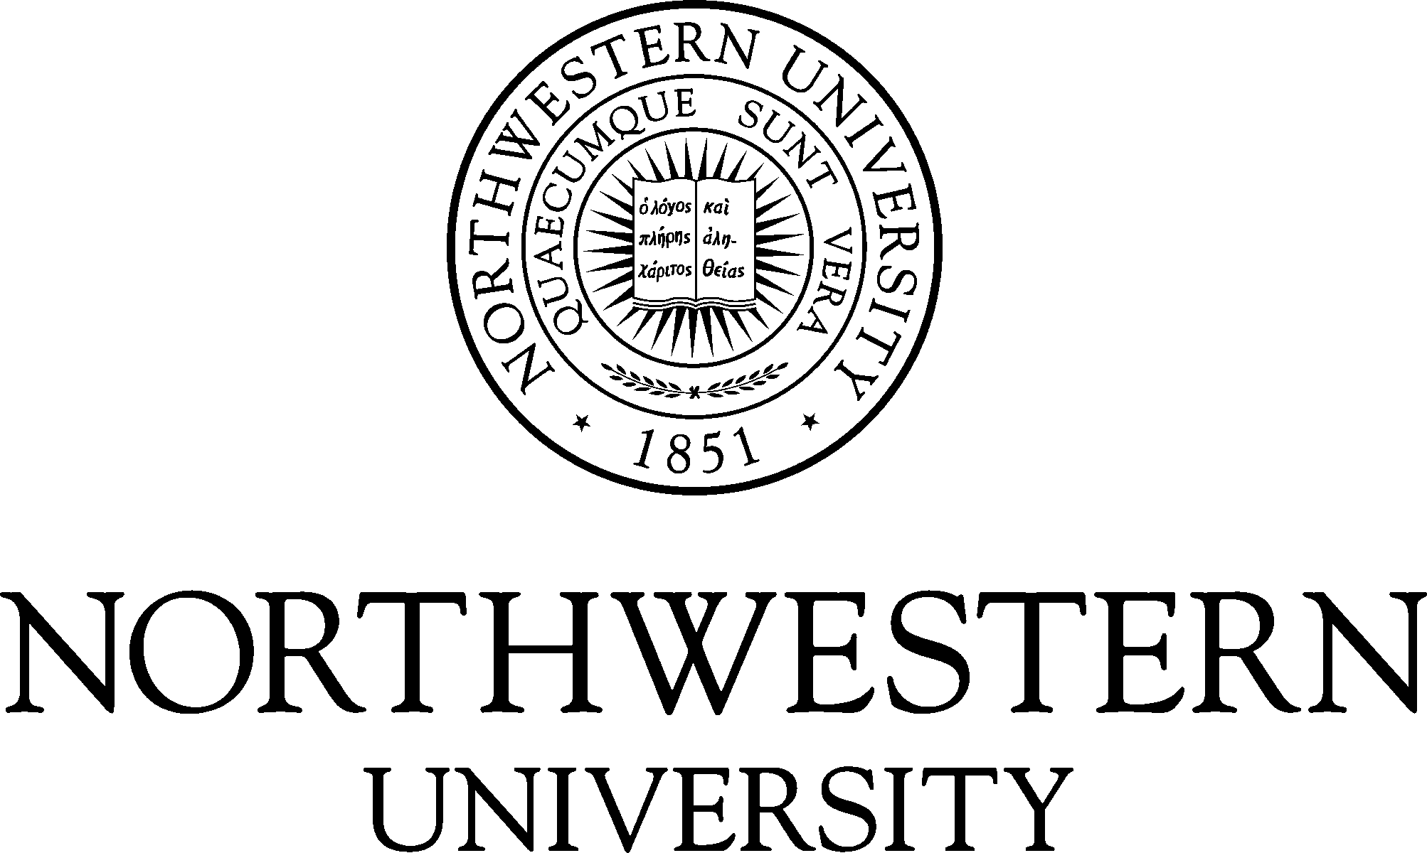

The Center for Applied Psychological and Family Studies
in conjunction with The Graduate School and The Family Institute
at Northwestern University

The Family Institute
Bette D. Harris Center
618 Library Place
Evanston, IL 60201
www.family-institute.org

Master of Science Program in Marriage and Family Therapy
Northwestern and Program Specific Application and Checklist
INSTRUCTIONS TO APPLICANTS

Application deadline: Applications for admission in the Fall 2017 are due by December 31, 2018. Applications for admission, together with all necessary supporting documents, must be on file by December 31, 2018 to guarantee consideration for admission the following academic year. We encourage you to submit your application as early as possible.

PART I: Northwestern University Graduate School Application Requirements
The Graduate School on-line application is available at https://www.applyweb.com/nugrad/index.ftl

Complete on-line application form.

An Application fee of $95.00 must be paid by credit card at application submission in order for application to be processed.

Digitally submit transcripts from all schools attended post high school through The Graduate School’s CollegeNET system

Digitally submit two (2) letters of recommendation through The Graduate School’s CollegeNET system

5,000 character Statement of Purpose (please see instruction below)

TOEFL scores for international students only (using code 1565).

PART II: Program-Specific Application Requirements
The following materials must be uploaded to the Graduate School on-line application

Program Specific Application – Master of Science in Marriage and Family Therapy Program

Resume or curriculum vitae

A current Photo of self (3x5)

Education Program Coordinator
Master of Science Program in Marriage and Family Therapy
The Family Institute
618 Library Place
Evanston, IL 60201

PLEASE DO NOT MAIL ANYTHING TO THE GRADUATE SCHOOL OFFICE
If you have any questions about the application process, please contact the Education Program Coordinator,
(847) 733-4300, extension 206 or ywardlow@family-institute.edu

Master of Science in Marriage and Family Therapy Program
Program Specific Application for Admission
Biographical Information
Last four of U.S. SSN #

Last Name | First Name | Middle | Maiden
Address |  | City | State | Postal Code
Home Phone | Cell Phone | Email Address

Employment and School History
Please attach a detailed resume or curriculum vitae accounting for all time periods from the start of your undergraduate studies to the present, beginning with your most recent activities. Please include schooling, part-time, summer and full-time work experience, travel, job search, etc. Specify dates, employer/school, job title, average number of hours per week, and primary responsibilities. Pay particular attention to describing activities in the field of mental health.

Disclosures
If your answer to either of the following questions is yes, explain fully on an attached sheet:

Do you have a known disability (physical or emotional) that requires special accommodations? ☐Yes ☐ No
(Please see University Policy statement below regarding non-discrimination)
Have you ever been suspended or required to withdraw from any school or college? ☐ Yes ☐ No

Have you ever been separated from any branch of the armed forces of the USA under conditions ☐ Yes ☐ No
other than honorable?
Have you ever pled “guilty” or “no contest” to, or been convicted of a crime? ☐ Yes ☐ No

Answering “yes” to these questions does not constitute an automatic bar from admissions. Factors such as date of offense, seriousness and nature of the violation and rehabilitation will be taken into account.

The Family Institute at Northwestern University requires all applicants who have received conditional admission to either the Master of Arts Program in Counseling Psychology or the Master of Science Program in Marriage and Family Therapy to complete an online background check to determine criminal history. Having an adverse criminal history finding does not necessarily preclude admission. Determinations are considered on a case-by-case basis. In the event that information from the background report is utilized in whole or in part in making an adverse decision with regard to an applicant's admission, before making the adverse decision, the Institute will provide the student with a copy of the consumer report and a written description of his or her rights under the federal Fair Credit Reporting Act.
University Policy Statements
It is the policy of Northwestern University not to discriminate against any individual on the basis of race, color, religion, national origin, sex, sexual orientation, marital status, age, handicap, or veteran status in matters of admissions, employment, housing, or services or in the educational programs or activities it operates, in accordance with civil rights legislation and University commitment. Any alleged violations of this policy or questions regarding the law with respect to non-discrimination should be directed to Director of Equal Employment Opportunity, Affirmative Action, and Disability Services, 720 University Place, Evanston, Illinois 60208-1147, 847/491-7458; Office of the Provost, Rebecca Crown Center, 633 Clark Street, Evanston, Illinois 60208-1101. Northwestern University reserves the right to change without notice any statement in this application concerning, but not limited to, rules, policies, tuition, fees, curricula, and courses.
Other Mental Health Programs Applied
Please circle the number of programs you are applying to in the following discipline:

Marriage & Family Therapy | 0 1 2 3+
Social Work | 0 1 2 3+
Clinical Psychology | 0 1 2 3+
Counseling Psychology | 0 1 2 3+

NU Statement of Purpose
Please respond to the following question in your NU Statement of Purpose within 5000 characters or less.

The Admissions Committee is most interested in you, the person, who seeks to be a marriage and family therapist. Your Statement of Purpose should be written so that we may better know you. Please respond to the following questions.

- What personal and family experience have influenced you interest in a career as a marriage and family therapist?
- What academic and professional experiences have influenced your interest in a career as a marriage and family therapist?
- What attracts you to the field of marriage and family therapy (as opposed to social work, counseling, or clinical psychology)?
- What attracts you to the MSMFT Program here at Northwestern University?
- Describe a time in your life when things didn’t go well for you. Describe the circumstances of this time and how you handled the challenges associated with it.

References
Applicants for degree programs are required to submit two (2) letters of reference. References should include, if possible, at least one addressing the applicant's academic background.

Reference Letters must be submitted through The Graduate School’s CollegeNet Application system.
First Name | Last Name | Position
Mailing Address | City | State | Postal Code
First Name | Last Name | Position
Mailing Address | City | State | Postal Code
First Name | Last Name | Position
Mailing Address | City | State | Postal Code

Should you have any questions please contact:

Yadira Wardlow, Education Coordinator
The Family Institute
618 Library Place
Evanston, IL 60201

Northwestern University does not find it possible to admit all applicants who meet its entrance requirements. The University, therefore, reserves the right to refuse admission to any applicant. The University also reserves the right to require the withdrawal of any student whose condition endangers his or her own health or the health of other students or precludes him or her from doing the required work.

I certify that all statements made in this application for admission to the Master of Science in Marriage and Family Therapy Program in The Graduate School of Northwestern University are correct, and I realize that all documents submitted in support of this application become the property of Northwestern University.

Signature | Date

